New Delhi, India

November 28, 2024

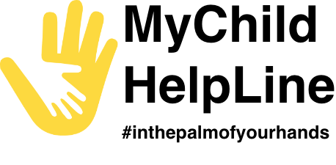

ADMIN PANEL GUIDE

*MyChild Helpline*

**Table of Contents**

1.0 INTRODUCTION 3

2.0 LOGIN 4

3.0 SUMMARY 5

4.0 MOBILE DATA 9

4.1 Mobile App Users 9

4.2 Counselling 10

4.3 Feedback 13

4.4 Mood Tracker 14

5.0 ADMIN 15

5.1 Admin Users 15

**5.1.1 Add User** 15

**5.1.2 Export Language** 17

**5.1.3 Import Language** 18

5.2 Geographical Area 20

**5.2.1** **Add Geographical Area** 20

5.3 Classification 22

**5.3.1** **Add Classification** 22

5.4 Helpline 24

**5.4.1** **Add Helpline** 24

5.5 Broadcast 26

**5.5.1** **Add Broadcast** 26

5.6 Mobile App Customize 28

**5.6.1** **U-Matter Chatline** 28

5.7 Language 30

**5.7.1 Export Language** 31

**5.7.2 Import Language** 32

# 1.0 INTRODUCTION

This user manual is developed to help the data administrators to understand the use of Admin Panel application and its modules. This application will have restricted access. Users with valid credentials will be able to login and access this application. The first user of this application is a super admin which is pre created in the system. The super admin will further create and manage the other users of this application.

The Data Manager application comprises of various data management modules. These modules allow the creation and management of the data and their elements.

**NOTE:** Valid login credentials are required to access the Admin Panel application

The Admin Panel application contains the following modules -

* Login
* Summary
* Mobile Data
* Mobile App Users
* Counselling
* Mood Tracker
* Feedback
* Admin
* Admin Users
* Classification
* Helpline
* Broadcast
* Mobile App Customization
  + U-Matter Chatline
* Language

Each of these modules are explained in detail in the following chapters.

# 2.0 LOGIN

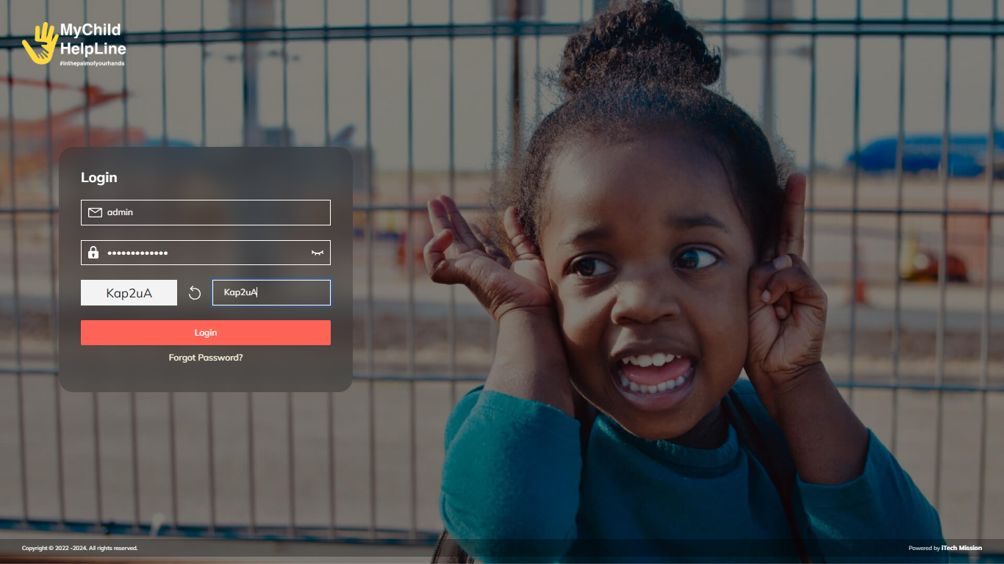The Admin Panel application can be accessed through a web browser (recommended browser - Google Chrome latest version). Enter the URL <https://mychildhelpline.itechmission.org/admin/> in the web browser. Enter the valid login credentials and correct captcha. Click on the **Login** button (see figure below).

# 3.0 Summary

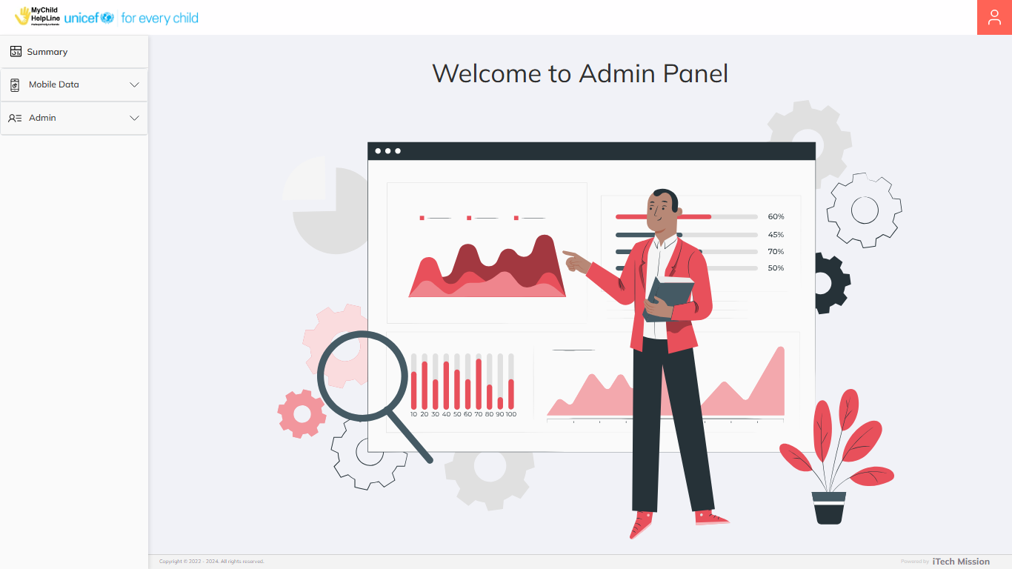The **Welcome page** will appear by default after the successful login (see below figure).

You can return to the Welcome Page from any module by clicking the **MyChild Helpline logo** located at the top-left corner of the screen.

To access this module, click on the **Summary** option from the left navigation menu. This module is area-driven and presents the aggregated data of mobile app users, counseling sessions,x and moods of the users (see below figure).

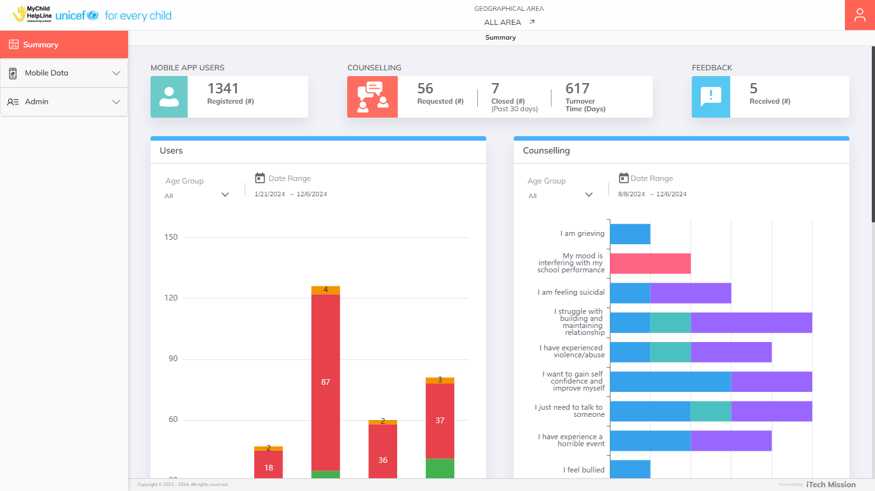By default, the data is displayed for **All Areas**. To view data for a specific area, click on the **Arrow icon** available next to the **Geographical Area** at the top of the page. This will open a pop-up 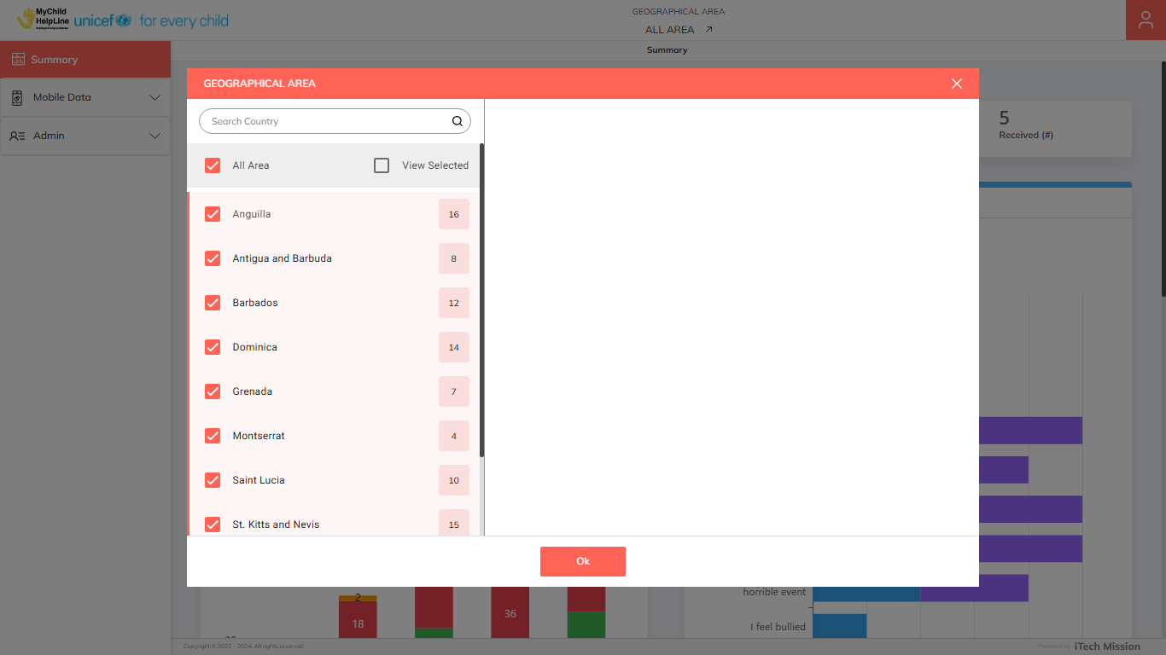window where you can select/deselect the required area (see below figure).

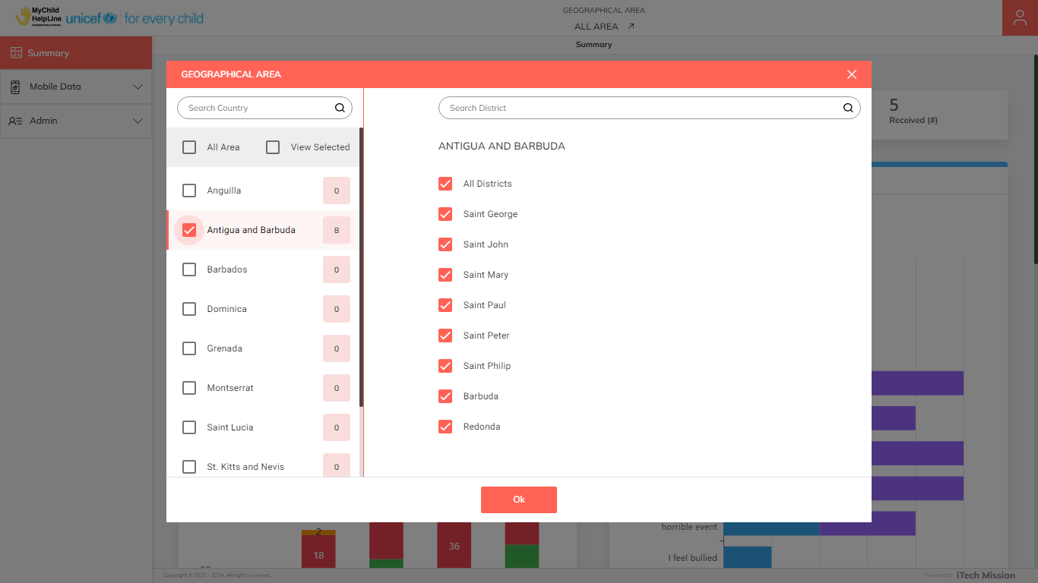The pop-up window provides an option to **Search** for a specific area. Click on the checkbox available with each area to select/deselect the specific area. If a single area is selected, the corresponding sub-national areas will appear on the right side and all will be selected by default. The total count of selected sub-national areas will be displayed along with the respective country name (see below figure).

Click on the **Ok** button to confirm the selections and view the data for the selected areas.

The summary on the following elements is shown at the top of the page in separate boxes –

* Mobile App Users
* Counselling
* Feedback

There are three widgets available below the summary that presents the aggregated data on registered mobile users, counselling and their moods submitted using the most suitable visualizations (see below figure).

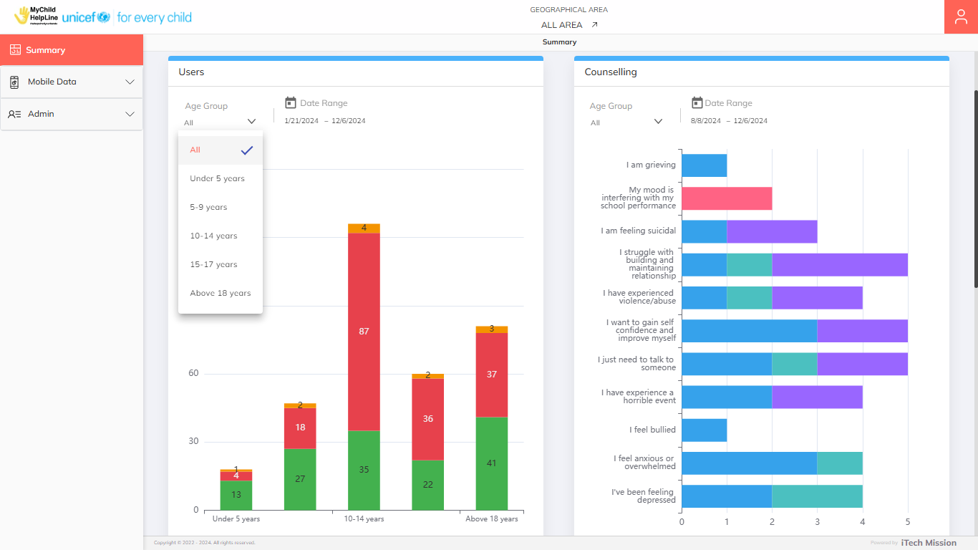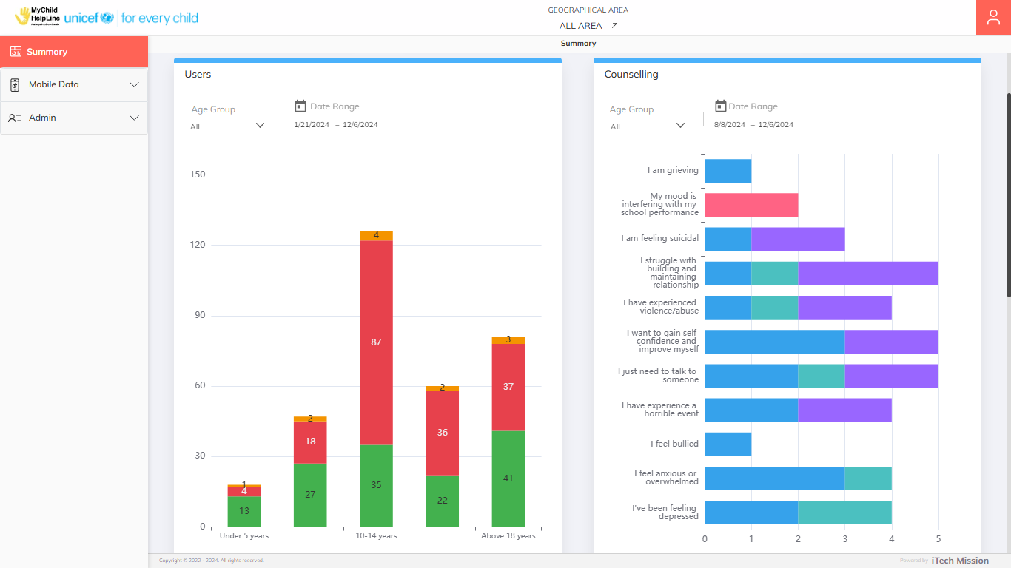Each widget has the option to filter data by **Age Group** and **Date Range**. The legends for the data are available at the bottom of each widget that help to understand the data presented (see below figure).

# 4.0 MOBILE DATA

The **Mobile Data** module allows to manage the data of mobile app users. This module comprises of the following sub-modules - Mobile App Users, Counselling, Feedback and Mood Tracker. All the mentioned sub-modules are area driven.

## **4.1 Mobile App Users**

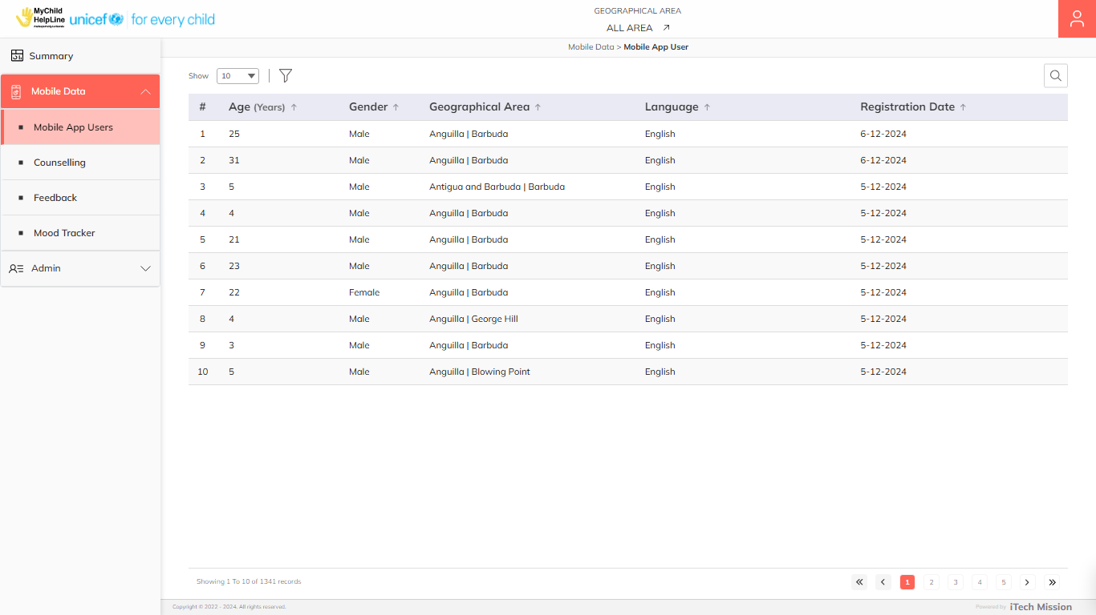To access this sub-module, click on the **Mobile App Users** option from the left navigation menu. The Mobile App Users sub-module allows admins to view the anonymized details of mobile app users in the table grid. You have the option to **Search**, **Sort**, **View** and **Filter** the existing list of mobile app users (see below figure).

Click the **Filter** icon located to the right of the pagination option to filter the records by –

* Age Group
* Gender
* Language
* Registration Date

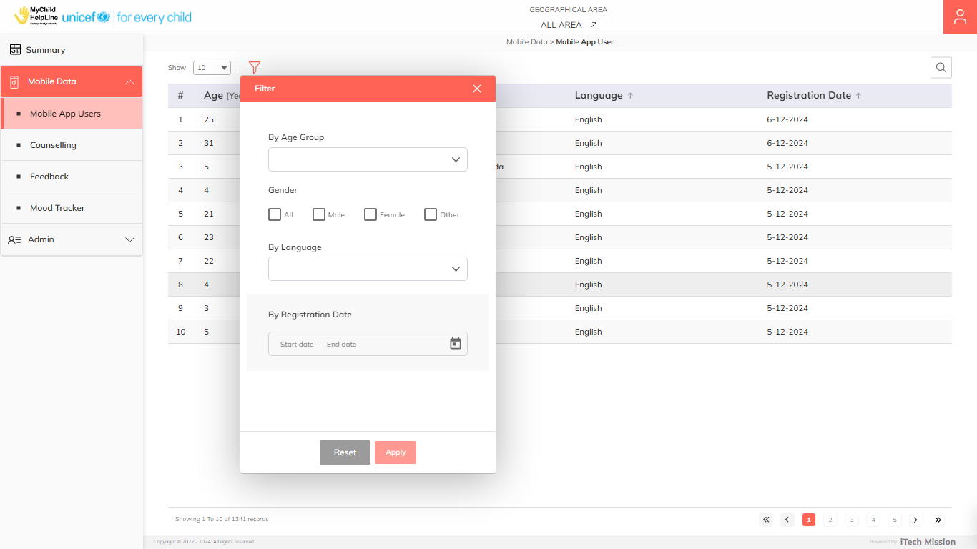Select the required filter and click on the **Apply** button to confirm. You can click on the **Reset** button to clear the applied filters (see below figure).

## **4.2 Counselling**

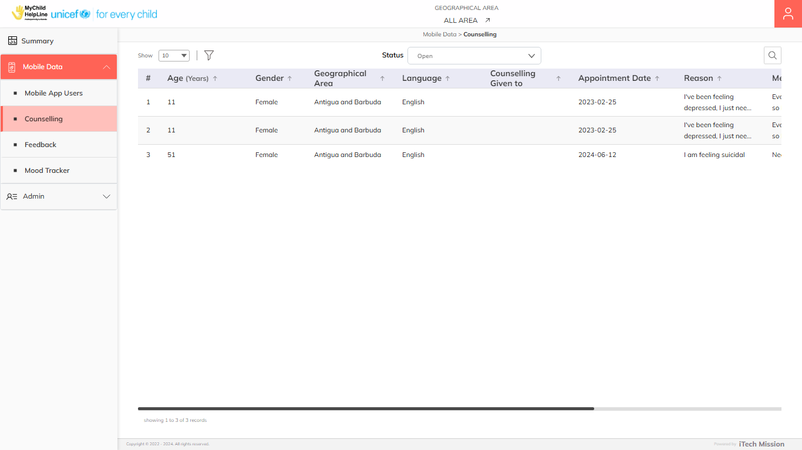To access this sub-module, click on the **Counselling** option from the left navigation menu. The **Counseling** sub-module allows admins to view counseling sessions booked by mobile app users in a table grid. You have the option to **Search**, **Sort**, **View** and **Filter** the existing list of counselling sessions (see below figure).

Click the **Filter** icon located to the right of the pagination option to filter the records by –

* First Name
* Last Name
* Age Group
* Gender
* Appointment Date

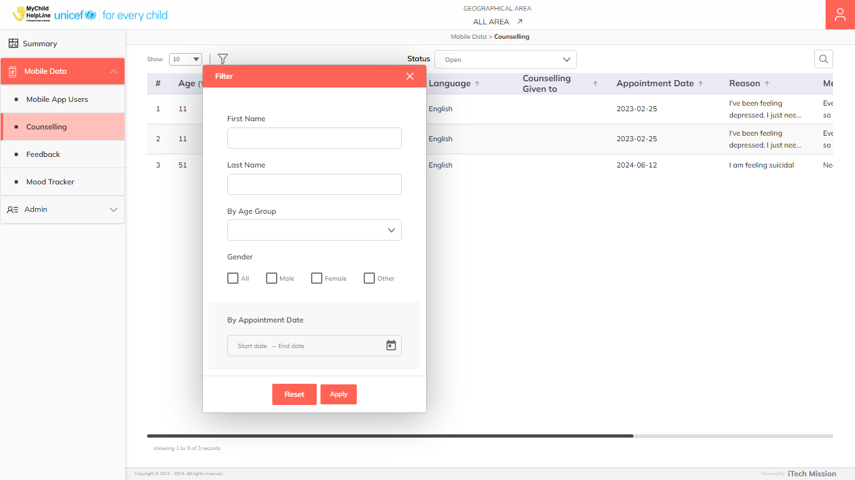Select the required filter and click on the **Apply** button to confirm. You can click on the **Reset** button to clear the applied filters (see below figure).

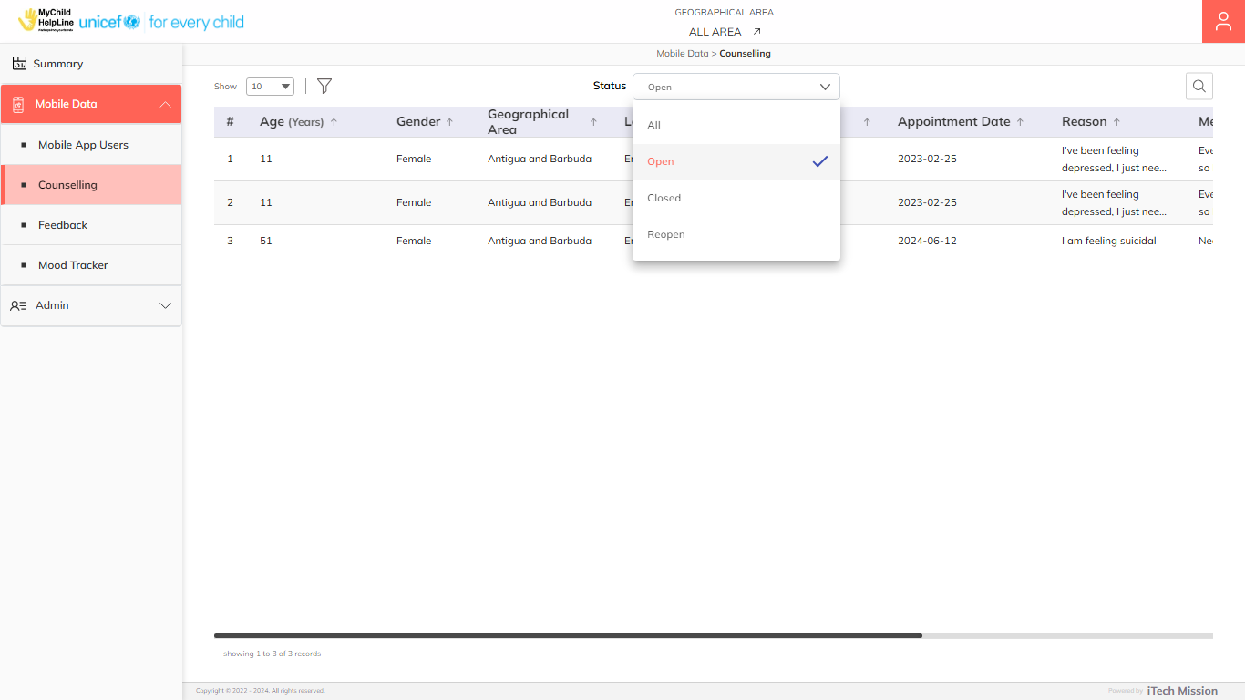Click the **Status** dropdown at the top to filter and view records based on their status: **Open**, **Closed**, **Reopen**, or **All** (see below figure).

Click on the **Arrow** icon available under the **Message** column to view the complete message in a 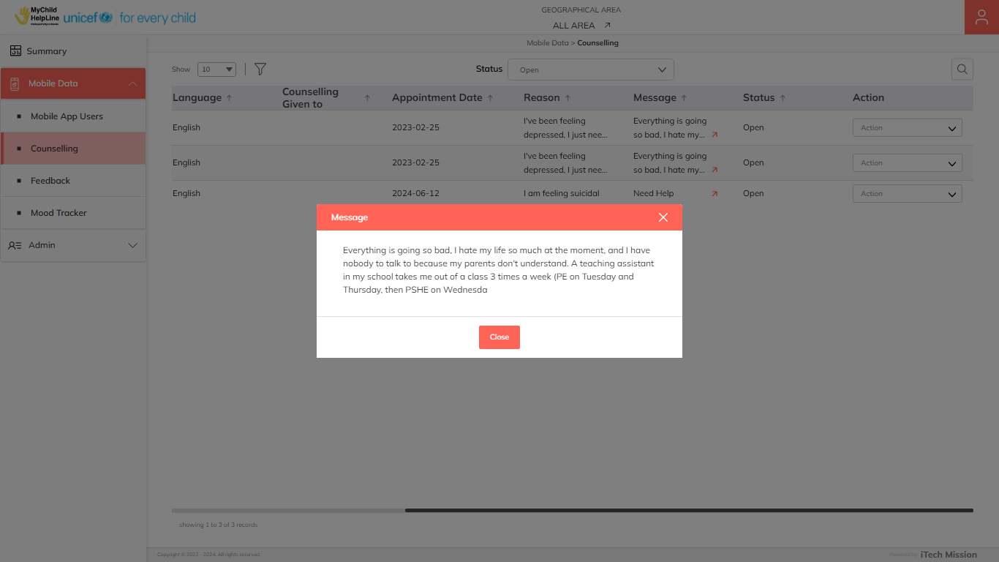pop-up box (see below figure).

You can perform the following actions on the **Open** counselling records –

* Mark Close
* View Details
* Delete

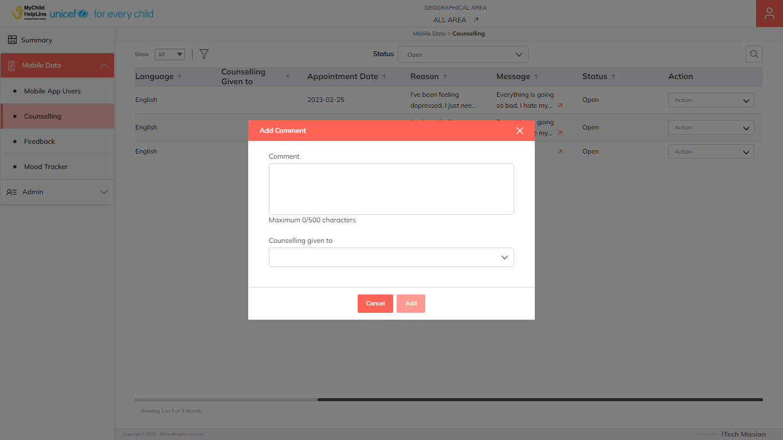Click on the **Mark Close** option from dropdown available under action column to enter the comment and select counselling given to option, then close the selected counselling session (see below figure).

Click on the **Add** button to confirm and move the record to **Closed** status. The record will now be automatically moved to the Closed list. You can perform the following actions on the **Closed** counselling records –

* Mark Reopen
* Delete

Click on the **Mark Reopen** option from dropdown available under action column to update the comment and reopen the selected counselling session. Click on the **Add** button to confirm and move the record to **Reopen** status. The record will now be automatically moved to the Reopen list. You can perform the following actions on the **Closed** counselling records –

* Mark Close
* Delete

## **4.3 Feedback**

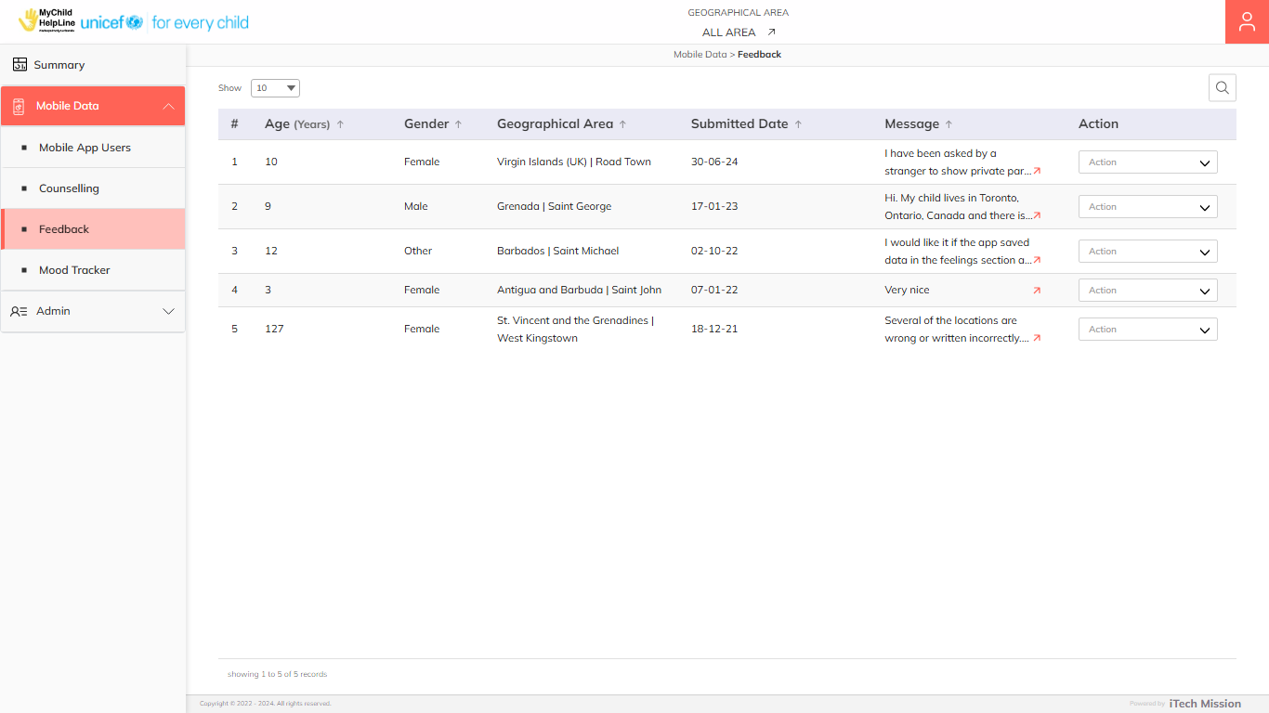To access this sub-module, click on the **Feedback** option from the left navigation menu. The **Feedback** module allows admins to view the feedback details submitted by mobile app users in the table grid. You have the option to **Search**, **Sort** and **Delete** the existing feedbacks (see below figure).

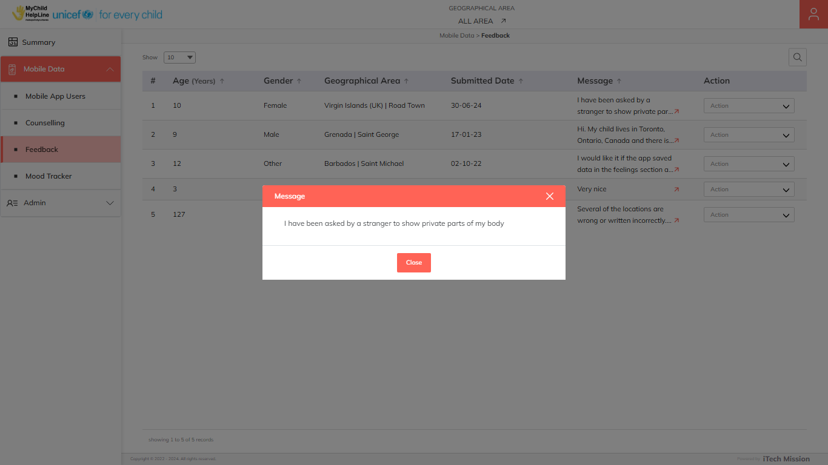Click on the **Arrow** icon available under the **Message** column to view the complete message in a pop-up box (see below figure).

Click on the **Delete** option available in the dropdown under the action column to delete the selected feedback.

Click on the **View Details** available in the dropdown under the action to view the details of the users.

## **4.4 Mood Tracker**

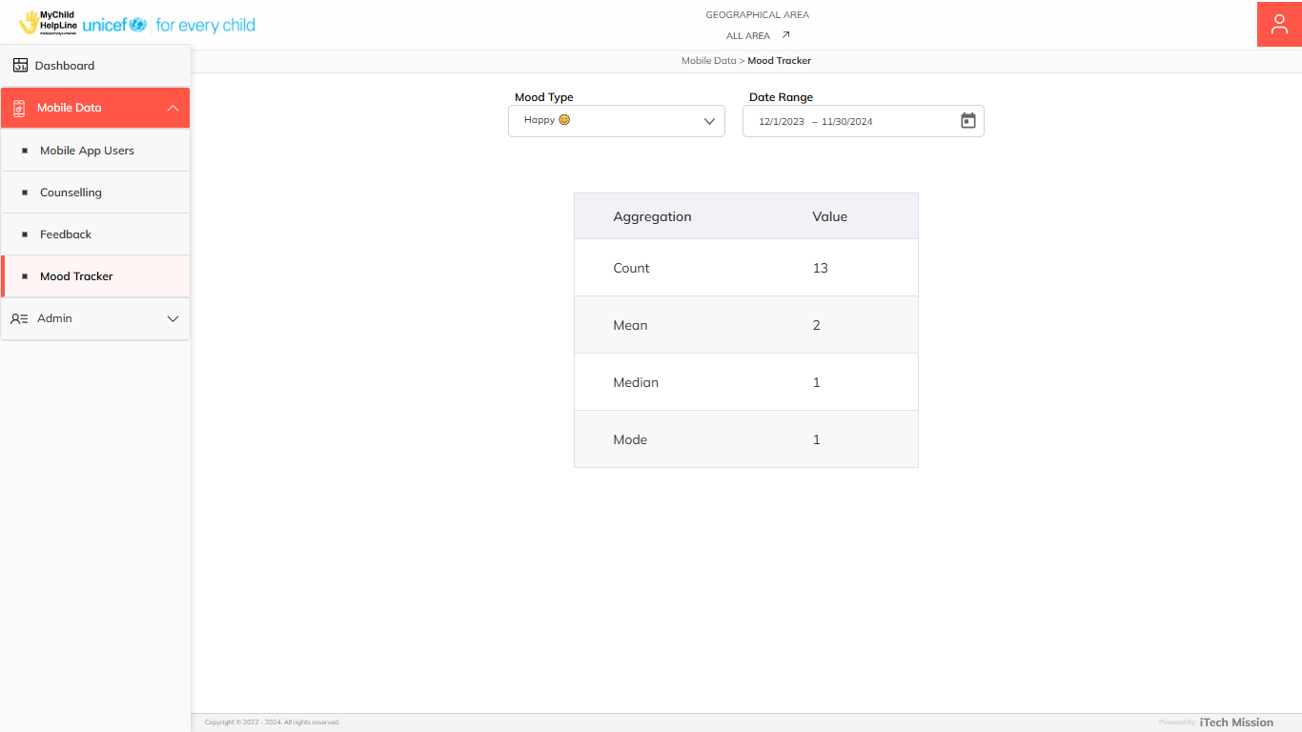To access this sub-module, click on the **Mood Tracker** option from the left navigation menu. The Mood Tracker sub-module provides a timeline-based aggregation of user psychosocial needs. It displays the aggregated data of moods submitted by mobile app users, including the total, mean, median, and mode calculations for a specified time period(see below figure).

You have the option to filter the data by **Mood Type** and **Date Range**.

# 5.0 ADMIN

Click on the **Admin** menu option from the left panel to access this module. This module has seven submodules – Admin Users, Geographical Area, Classification, Helpline, Broadcast, Mobile APP Customize and Language. It allows to manage the master list of these four elements in the database. Let us understand these submodules in detail.

## **5.1 Admin Users**

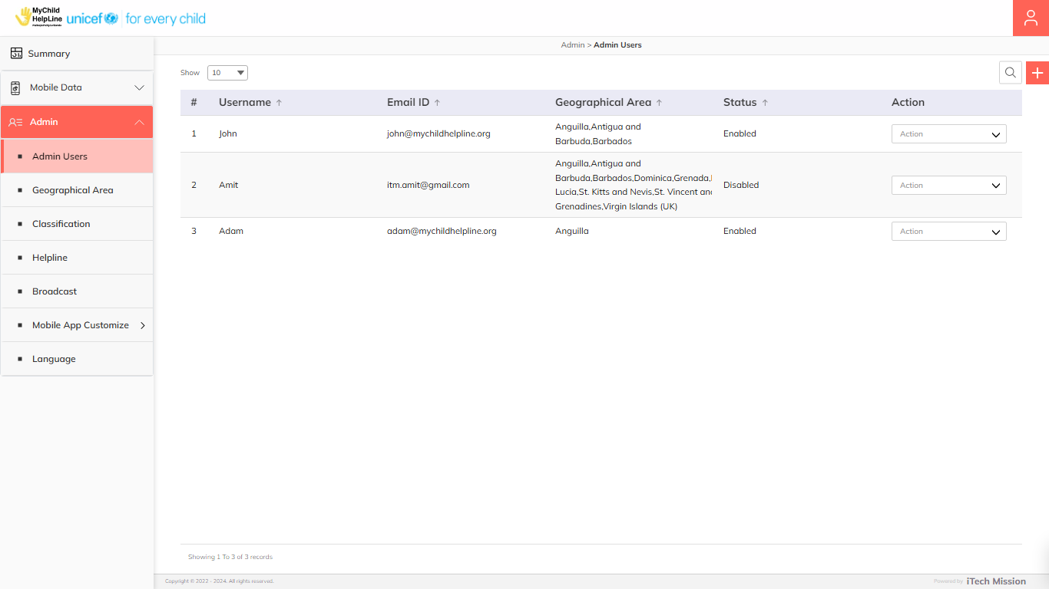Click on the **Admin** **Users** option from the Admin menu option in the left panel to access this module. This module allows super admin to manage the user master list. You have the option to add new users, view the list of existing users, search users from the list, edit and Show/Hide existing users (see figure below).

### **5.1.1 Add User**

****Click on the **Plus** button available to the right side of the page and enter the following details to create a new user.

* Enter user **Name**
* Enter **Email**
* Set **Password**
* Select **Country**

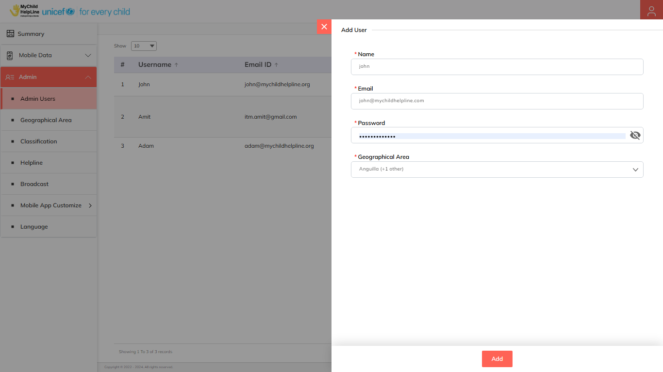All the above details are mandatory to be entered. Click on the **Add** button to save and confirm. You can now view the new user added in the list.

Click on the **Edit** option available in the action column to edit the details of the selected user. Edit the required detail and click on the **Update** button to save and confirm.

Click on the **Enable/Disable** option available in the action column to activate or deactivate the selected user. The disabled user will not be able login into the application.

Click on the **Delete** option available in the action column to delete the selected user. A confirmation popup appears, click on **Yes** to confirm deletion. The deleted users will not be able login into the application.

## **5.2 Geographical Area**

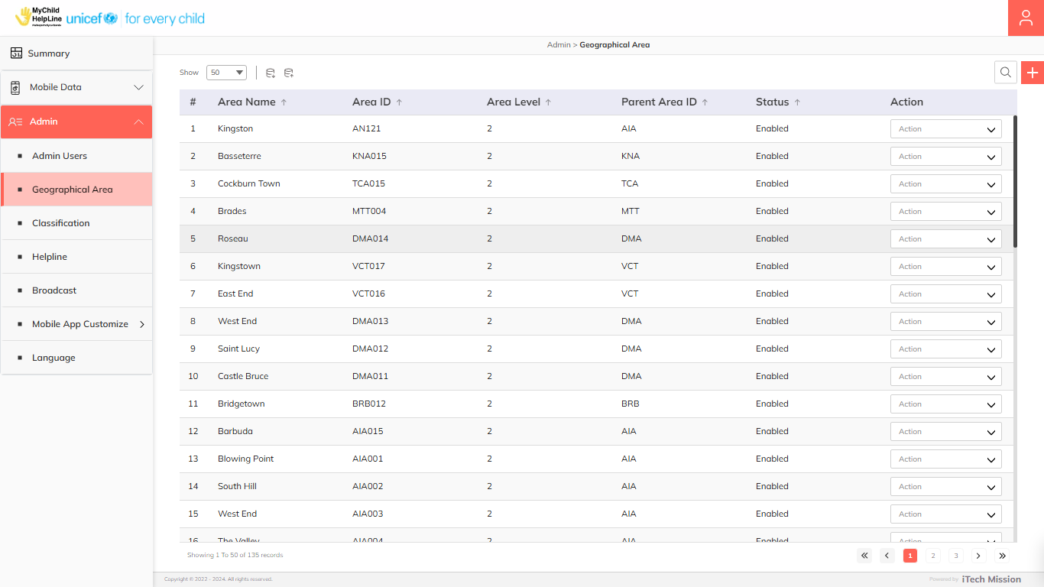Click on the **Geographical Area** option from the Admin menu option in the left panel to access this module. This module allows the super admin to manage the area master list. You have the option to add a new area, view the list of existing areas, sort the list, search area from the list, edit and show/hide existing areas (see below figure).

### **5.2.1 Add Geographical Area**

****Click on the **Plus** button available to the right side of the page and enter the following details to add a new area (see below figure).

* Select **Parent Area** (In case child area is added)
* Enter **Area ID**
* Enter **Name**

Blue color details are mandatory to be entered.

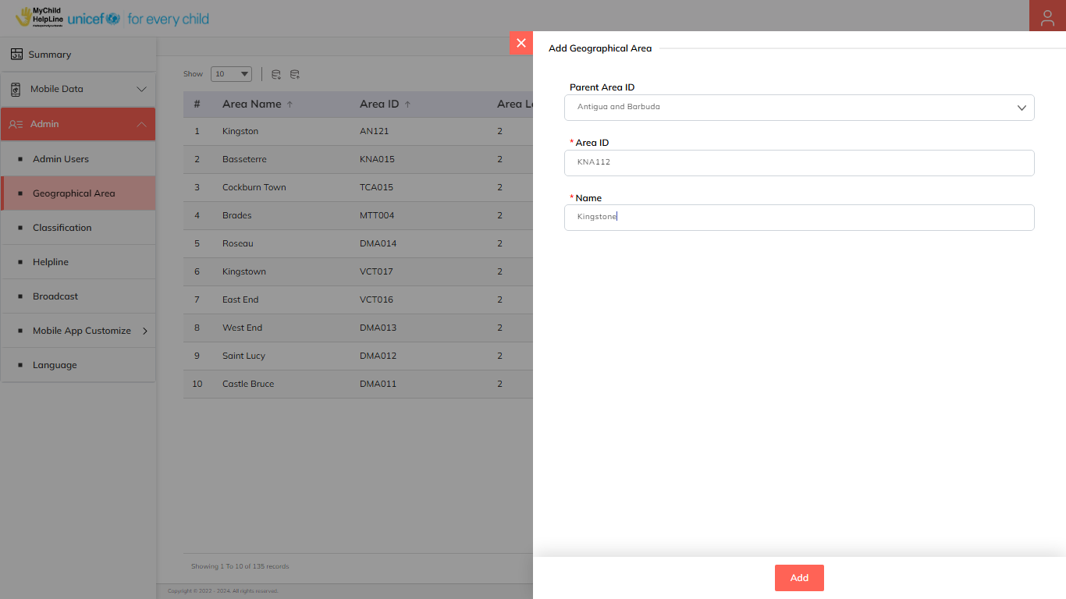Click on the **Add** button to save and confirm. You can now view the new area added in the area list.

Click on the **Edit** option available in the action column to edit the details of the selected area. Edit the required detail and click on the **Update** button to save and confirm.

Click on the **Enable/Disable** option available in the action column to show or hide the specific area. The hidden area will not be shown in the list of area throughout the application.

Click on the **Delete** option available in the action column to delete the selected area. A confirmation popup appears, click on **Yes** to confirm deletion. The deleted area will not be shown in the list of areas throughout the application.

### **5.1.2 Export Language**

Select the category and click on the **Export** button to download the Area template.

The template will have the following columns.

|  |  |
| --- | --- |
| **AreaID** | The ID of the area to be imported. |
| **AreaName** | The name of the Area to be imported. |
| **AreaLevel** | The level at which the area is in the country. |
| **AreaParentID** | The area ID of the parent area. |

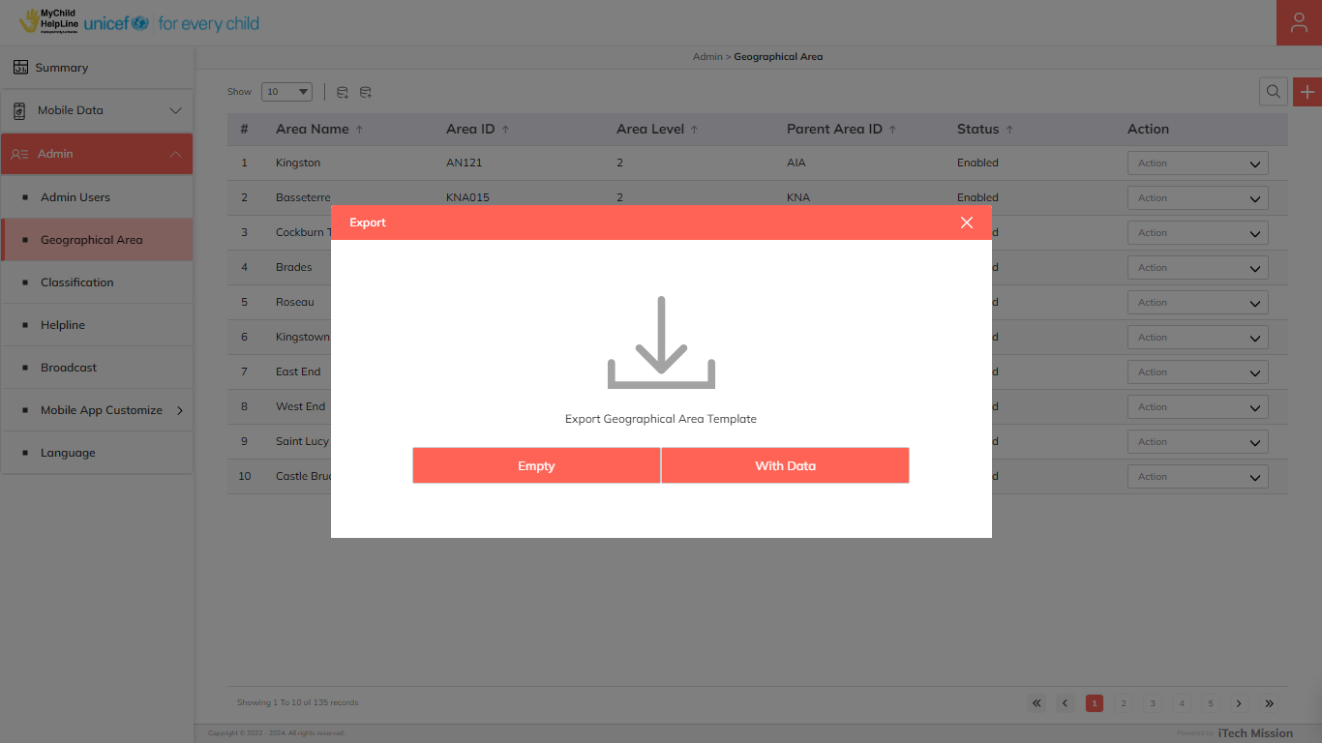Click on the **Empty** option when exporting to download an empty template (see below figure).

Click on the **With Data** option when exporting the Area available in the database.

### **5.1.3 Import Language**

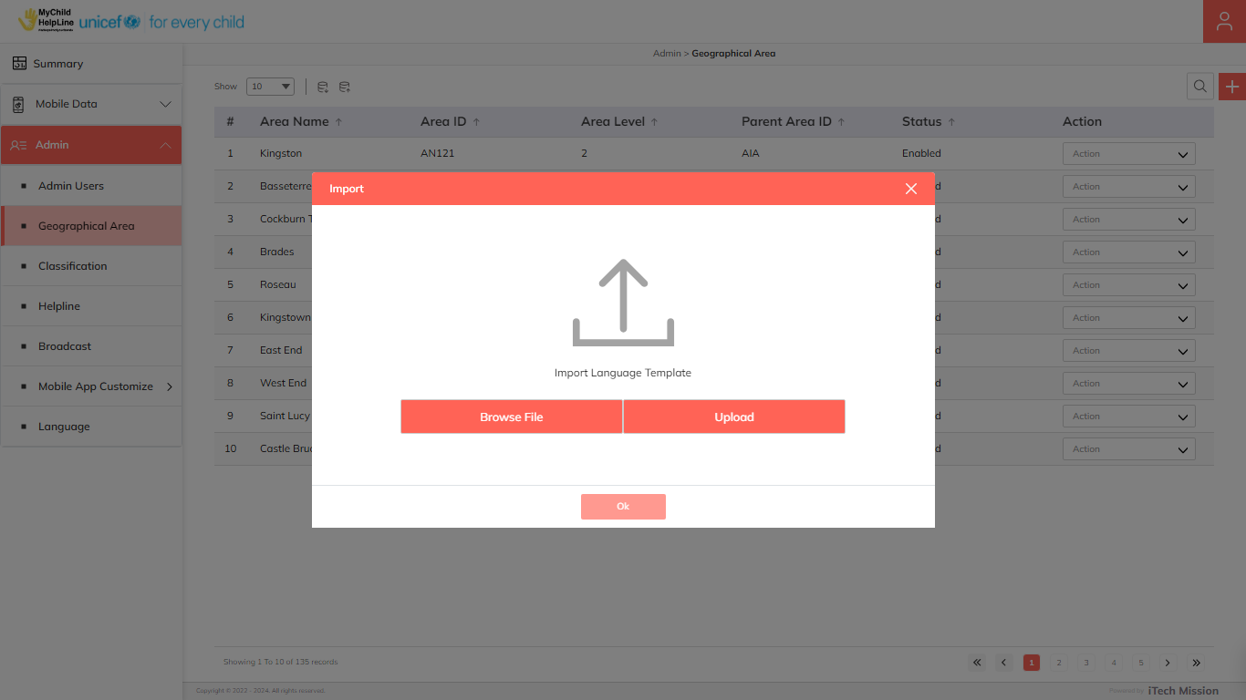Click on the **Import** button to browse the template file and upload the Area into the database. To upload an area into the database, first, enter the area in the template and save it. Then click on the **Browse** **File** button to select the saved file. Now, click on the **Upload** button to start the import process.

After the successful import process, a summary of the last import will appear which will show the count of successfully imported records out of the total records. An error log will be generated to report on unsuccessful imported records which you can access in the Log module.

## **5.3 Classification**

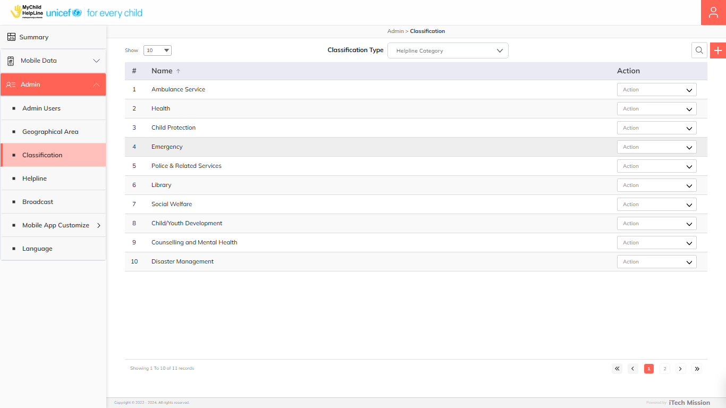This module allows the super admin to manage the master list of classification type Helpline Category, Resource Category, Reason for Counselling, Broadcast Category and Broadcast Category. You have the options to add new elements to all the types of master lists, view the list of existing master list filtered by classification type, sort each list, search elements of selected classification type from the list, edit and enable/disable existing elements of selected type from the list (see below figure).

### **5.3.1 Add Classification**

Click on the **Plus** button available to the right side of the page. Select classification type and enter the following details to add a new element.

* Enter **Name**

Click on the **Add** button to save and confirm add new element to the master list.

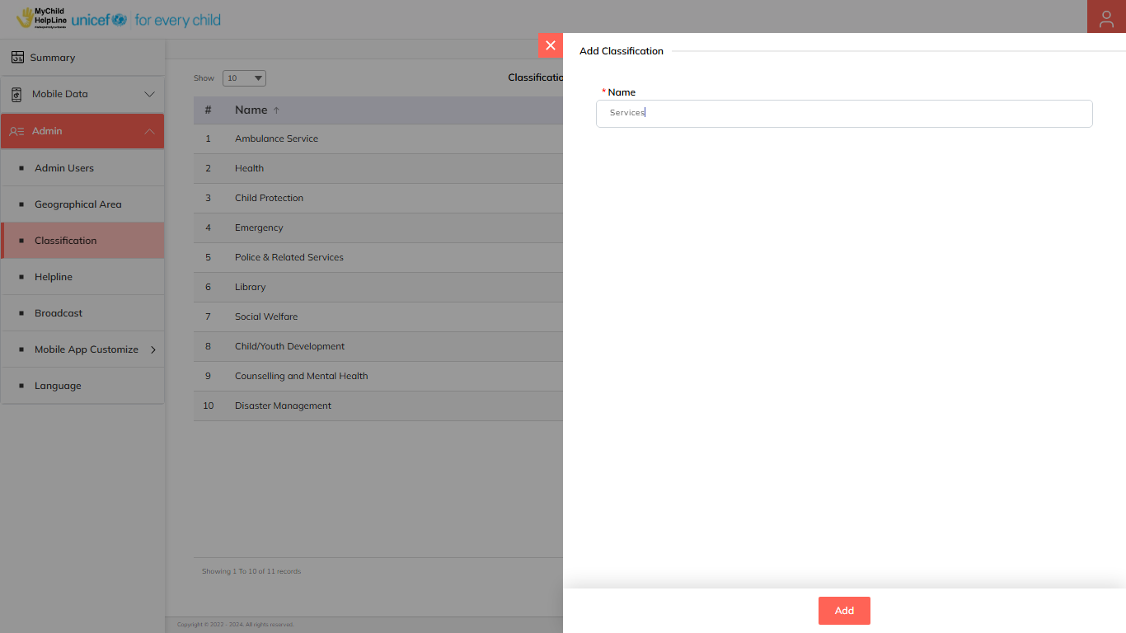Click on the **Edit** option available in the action column to edit the details of the selected element. Edit the required detail and click on the **Update** button to save and confirm.

Click on the **Delete** option available in the action column to delete the selected element. A confirmation popup appears, click on **Yes** to confirm deletion. The deleted element will not be shown in the list of classification type of element throughout the application.

## **5.4 Helpline**

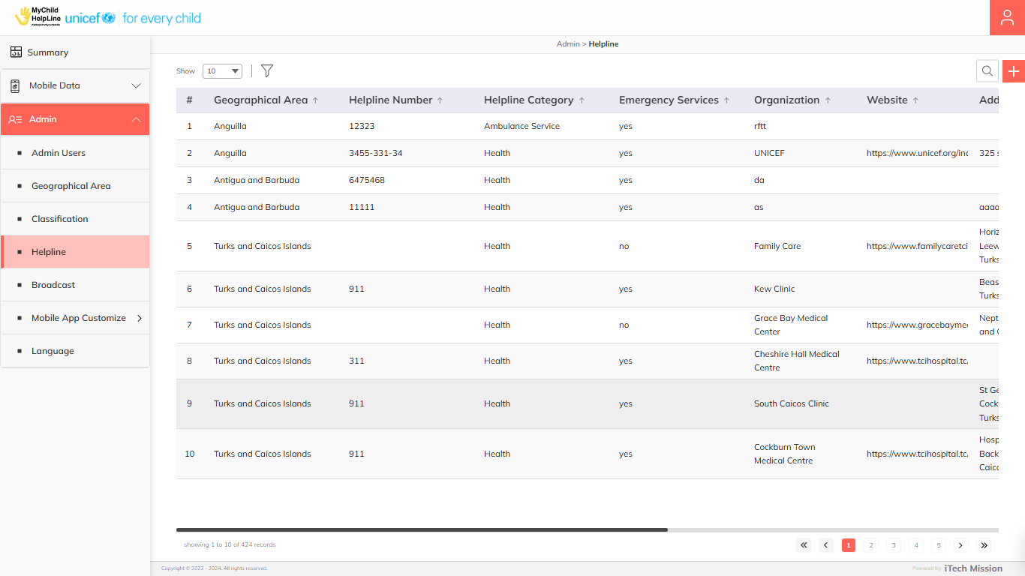Click on the **Helpline** option from the Admin menu option in the left panel to access this module. This module allows super admin to manage the list of emergency and support services of all the countries available in the database. You have the option to add a new record, view the list of existing records, search a record from the list, edit and Enable/Disable existing records (see figure below).

### **5.4.1 Add Helpline**

****Click on the **Plus** button available to the right side of the page and enter the following details to add a new helpline record (see below figure).

* Select **Country**
* Select **District**
* Enter **Helpline Number**
* Select **Helpline Category**
* Select **Emergency Service Status**
* Select **Name of the Organization**
* Enter **Address**
* Enter **Website URL**
* Enter **Contact Number**
* Enter **Email**
* 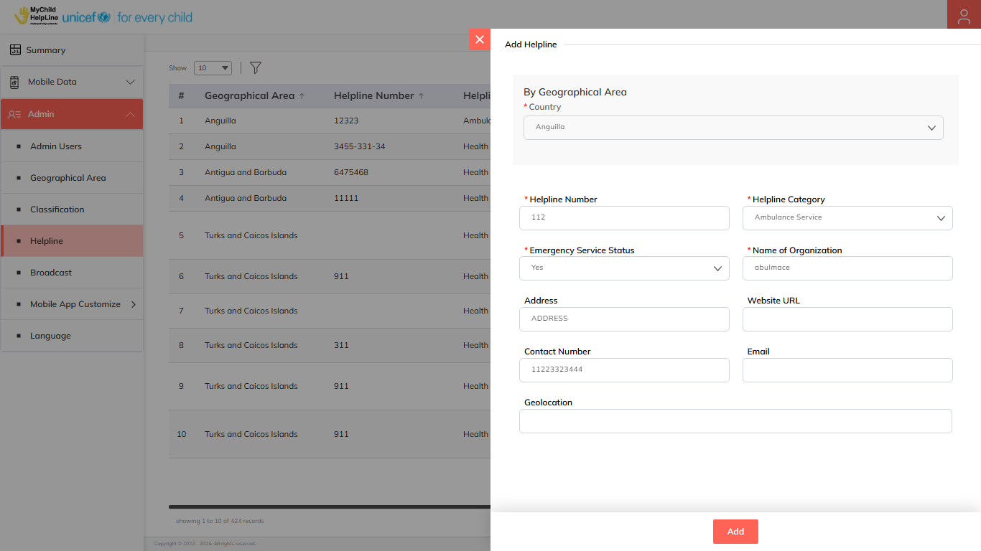Enter **Geolocation**

Blue color details are mandatory to be entered. Click on the **Add** button to save and confirm. You can now view the new record added in the list.

Click on the **Edit** option available in the action column to edit the details of the selected record. Edit the required detail and click on the **Update** button to save and confirm.

Click on the **Enable/Disable** option available in the action column to show or hide the selected helpline record in the mobile application.

Click on the **Delete** option available in the action column to delete the selected record. A confirmation popup appears, click on **Yes** to confirm deletion. The deleted helpline record will not be shown in the mobile application.

## **5.5 Broadcast**

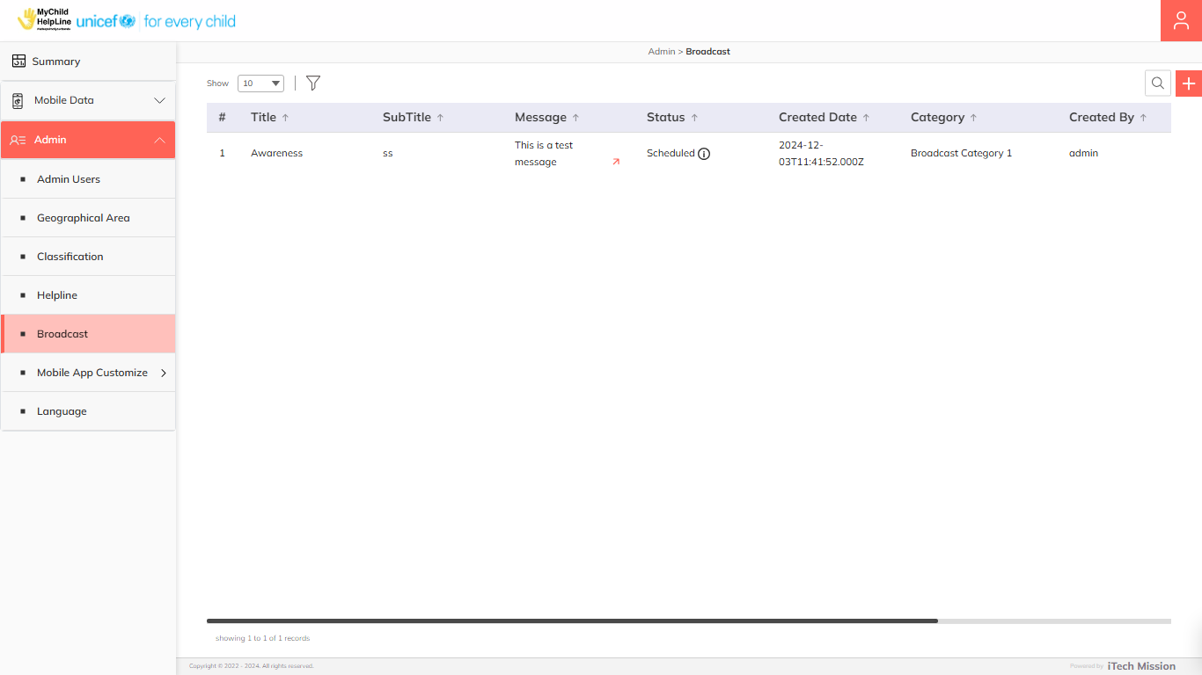Click on the **Broadcast** option from the Admin menu option in the left panel to access this module. This module allows admin users to create and manage the broadcast messages for their assigned country users. You have the option to add a new record, view the list of existing records, search a record from the list, edit and Enable/Disable existing records (see figure below).

### **5.5.1 Add Broadcast**

****Click on the **Plus** button available to the right side of the page and enter the following details to add a new broadcast message (see below figure).

* Enter Title
* Enter Subtitle
* Enter Message
* Select **Category**
* Enter **Broadcast Date**
* Select **Geographical Area**

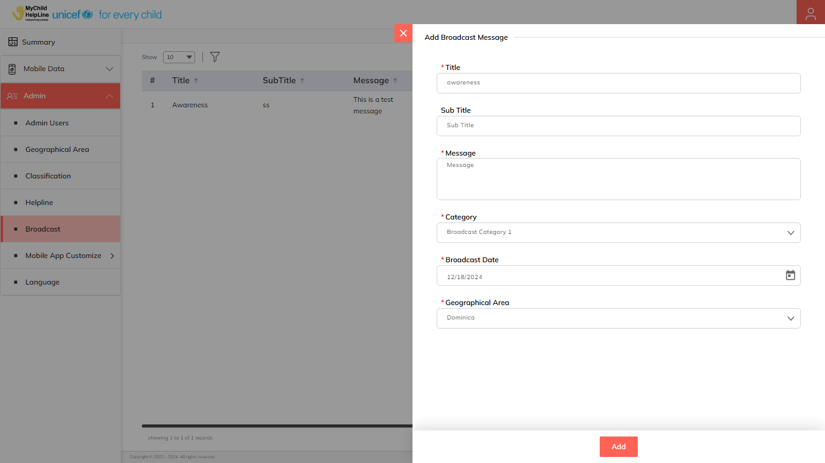All the details are mandatory to be entered. Click on the **Add** button to save and confirm. You can now view the new message added in the list.

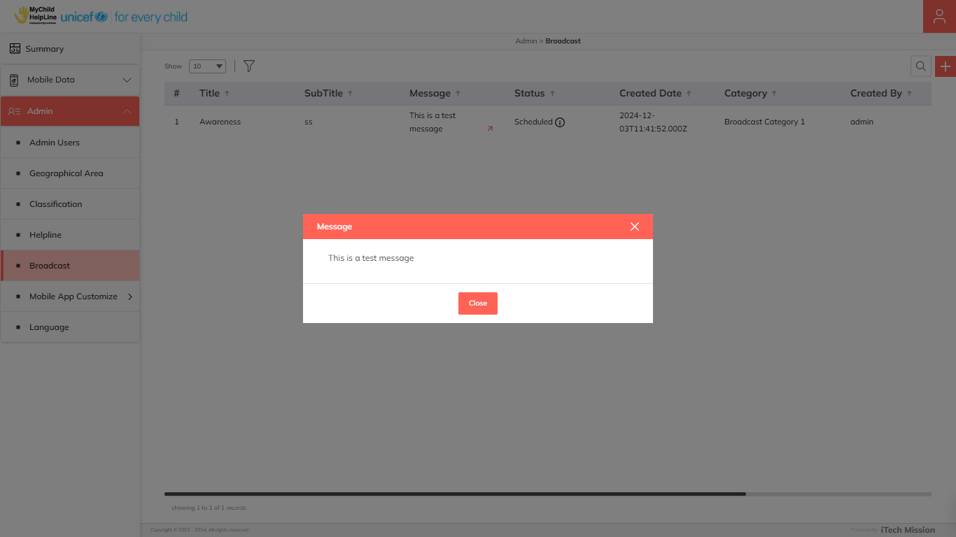Click on the **Arrow** icon available under the **Message** column to view the complete message in a pop-up box (see below figure).

Click on the **Delete** option available in the action column to delete the selected message. A confirmation popup appears, click on **Yes** to confirm deletion. The deleted message will be deleted from the list.

Click on the **Send** option available in the action column to send the selected message to assigned countries. The sent messages will be shown in the notification section of the mobile application.

## **5.6 Mobile App Customize**

Click on the **Mobile App Customize** menu option from the left panel to access this module. This module comprises of one submodule – U-Matter Chatline. Let us understand this submodule in detail.

### **5.6.1 U-Matter Chatline**

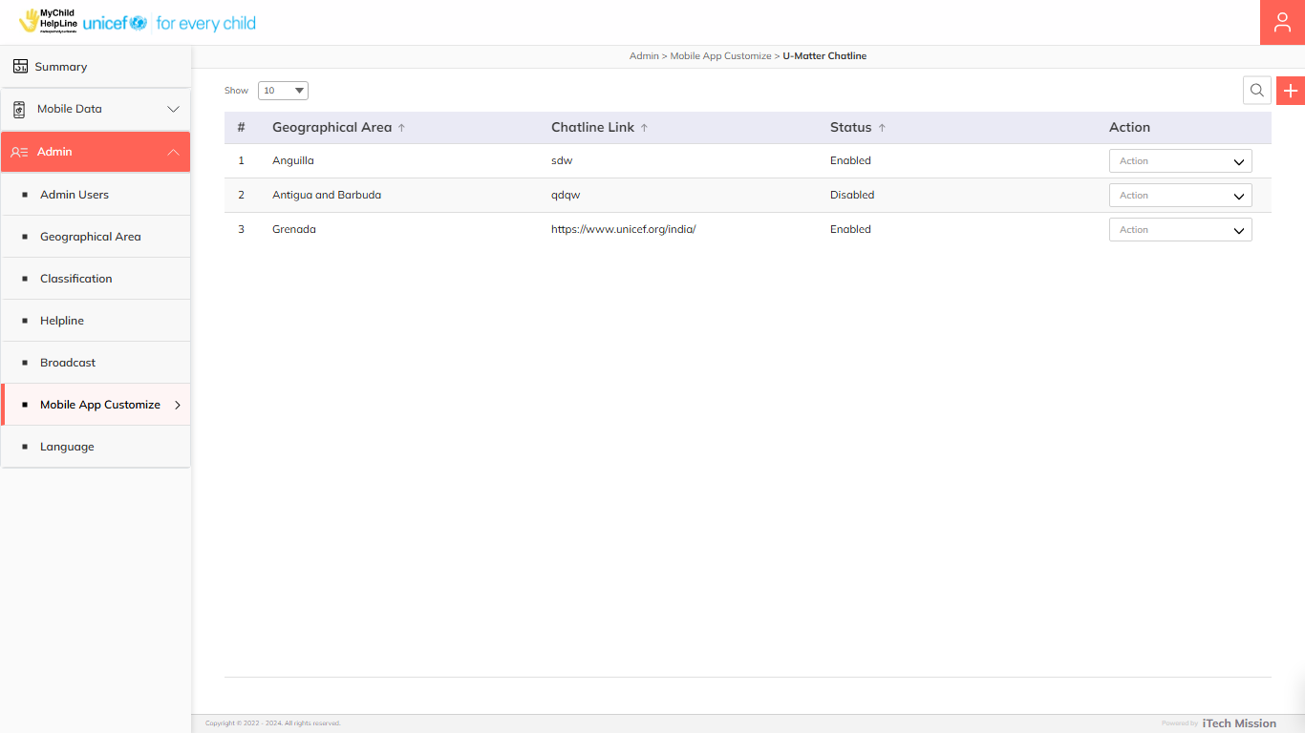This module allows the Super Admin to assign one WhatsApp chat link to a country. You have the option to add a new entry, view the list of existing entries, search an entry from the list, edit, and Enable/Disable existing entries (see figure below).

**Add U-Matter Chatline**

****Click on the **Plus** button available to the right side of the page and enter the following details to add a new chatline information (See below figure).

* Select **Country**
* Enter **Chat Link**

All details are mandatory to be entered.

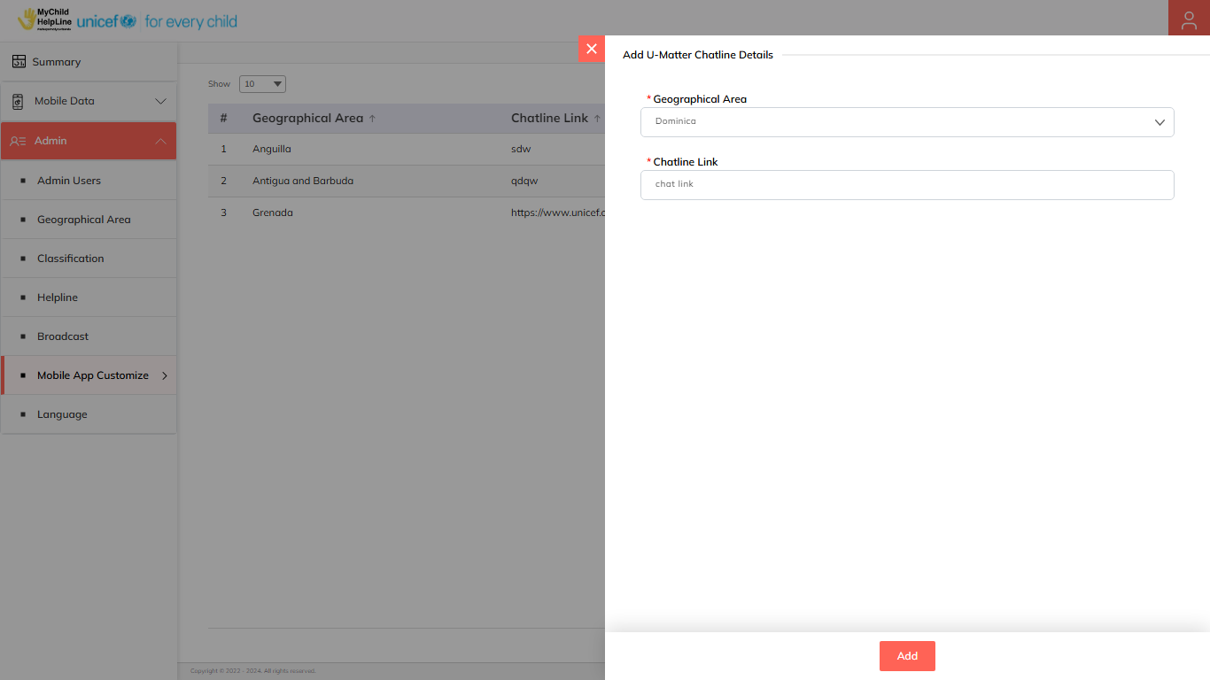Click on the **Add** button to save and confirm. You can now view the new area added in the area list.

Click on the **Edit** option available in the action column to edit the details of the selected record. Edit the required detail and click on the **Update** button to save and confirm.

Click on the **Enable/Disable** option available in the action column to show or hide the specific record. The hidden chatline record will not be shown in the mobile application.

Click on the **Delete** option available in the action column to delete the selected record. A confirmation popup appears, click on **Yes** to confirm deletion. The deleted record will not be shown in the list and also in the mobile application.

## **5.7 Language**

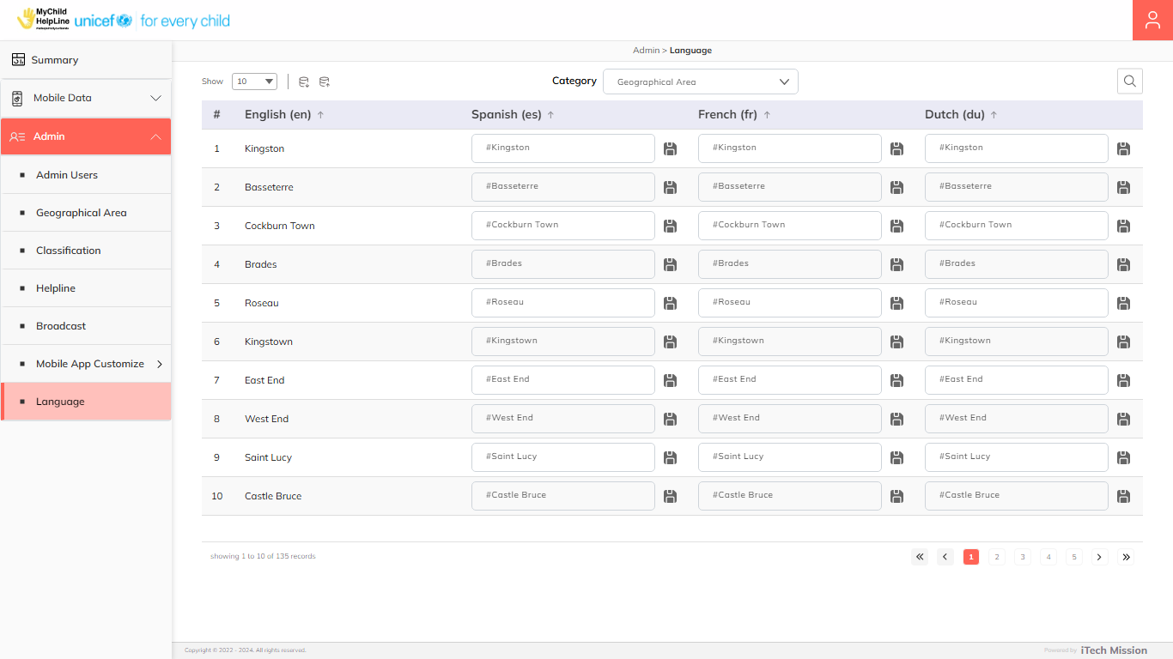Click on the **Language** option from the Admin menu option in the left panel to access this module. This module allows admin to manage language translated strings used in the portal in four languages: English, Dutch, French and Spanish. You have options to export and import language templates, enter/update strings in Dutch, French and Spanish of existing English strings. The first view in this module shows the list of existing strings grouped by categories: Geographical area, and Classification. You can enter and edit the translated strings in the required language and click on the **Save** button to confirm. You can also export and import the translation file in CSV (Comma Separated Value) file format.

### **5.7.1 Export Language**

Select the category and click on the **Export** button to download the language template with the strings available in the database of the selected category.

The template will have the following columns.

|  |  |
| --- | --- |
| **English** | The string available in the portal in English language. |
| **Dutch** | The translation of the English string in Dutch language. |
| **French** | The translation of the English string in French language. |
| **Spanish** | The translation of the English string in Spanish language. |

Click on the **Empty** option when exporting to download an empty template (see below figure). 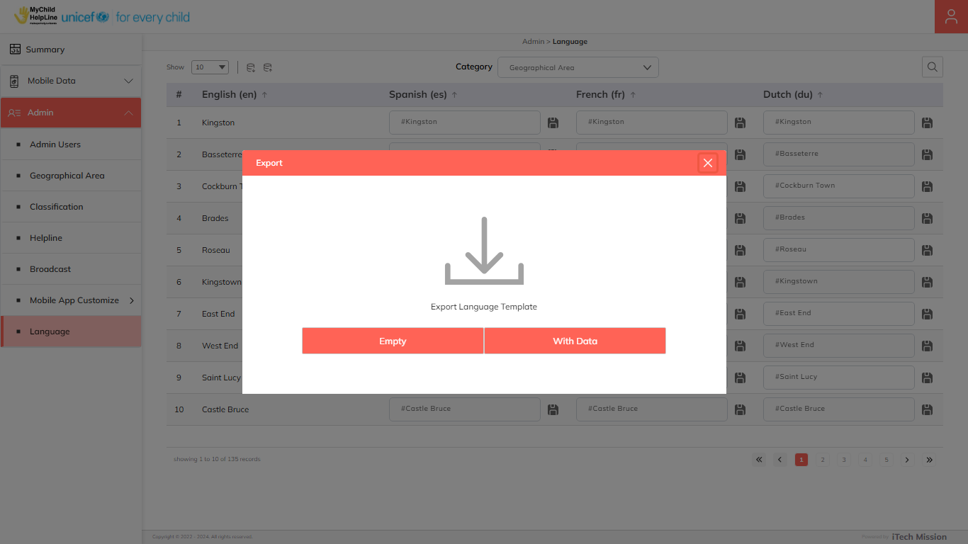

Click on the **With Data** option when exporting to download strings available in the database of the selected category.

### **5.7.2 Import Language**

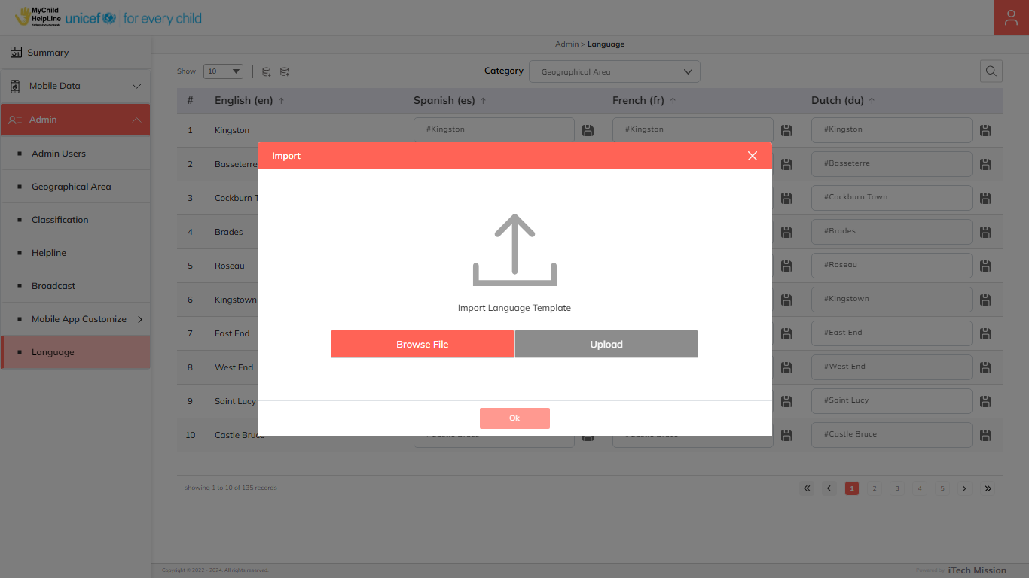Click on the **Import** button to browse the template file and upload the translated strings into the database. To upload the strings into the database, first enter the strings in the template and save them. Then click on the **Browse** **File** button to select the saved file. Now, click on the **Upload** button to start the import process.

After the successful import process, a summary of the last import will appear which will show the count of successfully imported records out of the total records. An error log will be generated to report on unsuccessful imported records which you can access in the Log module.

---- End of the Document ----